Exercise 1 - SWOT Analysis

A SWOT analysis is a widely used diagnostic model to identify internal and external factors likely to affect operational plans. SWOT is an acronym which stands for:
- Strengths
- Weaknesses
- Opportunities
- Threats.

Part 1:

Using your current workplace setting, undertake a SWOT analysis to identify factors that may support or undermine your operational plan. If you do not currently have an operational plan, base your answers on a work area that you know or have researched.

Summarise your findings by completing the template.

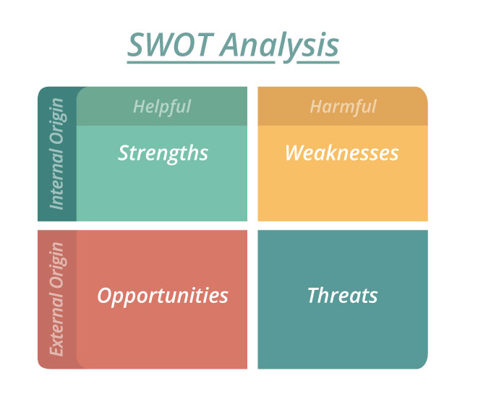

 | Helpful | Harmful
Internal Origin | Strengths | Weaknesses
External Origin | Opportunities | Threats

Part 2:

Having completed the SWOT analysis, identify one factor from each area and complete the template below.

Factor | How could this factor impact the operational plan?  Be specific when describing the current impact. | What actions could you take to either maximise or minimise the impact of this factor?  Identify 2-3 specific actions that could be implemented. | If actions were successfully implemented, what would be the likely impact?  Identify the specific impact the changes would likely have on your operational plans.
Strength:
Weakness:
Opportunity:
Threat:

